

**APTECH LEARNING PAKISTAN**

Patch Metro Star Gate

**DEVELOPER SUPER LEAUGE**

PROJECT REPORT

**E-commerce Website for a Mirror Selling**

**Supervised by**

Sir Abdul Wahab Amir

**GROUP MEMBERS**

* Muhammad Asif

•Najeeb-ur-Rehman

* Zainab Khan

Shah Faisal Colony Flyover, Faisal cantonment, Karachi City, Sindh

**TABLE OF CONTENTS**

Contents

TABLE OF CONTENTS ................................................................................................................................2

1. INTRODUCTION .................................................................................................................................... 3

1.2. PROJECT EXECUTIVE SUMMARY................................................................................................... 3

1.3. BACKGROUND..................................................................................................................................... 4

1.4. PROJECT OVERVIEW ......................................................................................................................... 4

1.5. PROJECT OBJECTIVES....................................................................................................................... 5

1.6. PROJECT SCOPE.................................................................................................................................. 6

2. ANALYSIS AND REQUIRMENTS ....................................................................................................... 7

2.1. PROJECT REQUIREMENTS ...................................................................................................... …...8

2.2. DFD ...................................................................................................................................................…9

2.3. FLOWCHART .................................................................................................................................…9

2.4. PROTOTYPE........................................................................................................................................10

3. HOME PAGE AND PRODUCT PAGE…………………………………………………………………11

4. CONCLUSION.........................................................................................................................................12

**Page # 2**

1. **INTRODUCTION**

This project aims to design an e-commerce website that showcases a brand's products and offers a seamless user experience. The website will have a clean and modern mirror that is responsive across all devices. The homepage, categories, and about us & contact us pages will all have specific design requirements to ensure a comprehensive view of the products and an easy purchase process. At Clear Reflection Mirror, we're dedicated to offering a diverse selection of high-quality mirrors to meet your unique needs and preferences. Our mission is simple: to provide you with the finest mirrors designed to reflect your distinct taste and personality. Whether you're searching for a classic, ornate mirror to enhance the elegance of your home, a sleek and modern mirror to create a contemporary ambiance, or a custom-crafted masterpiece to fit your specific vision, we've got you covered.

**1.1. PROJECT EXECUTIVE SUMMARY**

The Mirror Selling Website is a project aimed at creating an online platform for selling a diverse range of high-quality mirrors. The website will provide customers with an easy-to-navigate catalog of mirrors in various styles, from classic to contemporary, and offer customization options for personalized mirror designs. It will prioritize exceptional customer service, competitive pricing, and secure online shopping. The project seeks to create a user-friendly and convenient shopping experience for those looking to enhance their living spaces with stylish and functional mirrors. The categories page will provide users with a comprehensive view of the product, including multiple product images, descriptions, sizes, colors, and reviews. The cart and checkout pages will be designed to make the purchase process as easy as possible, with clear and concise information regarding total cost, shipping, and payment options. The website will be designed to provide a seamless user experience, with easy navigation, clear product information, and a user-friendly checkout process. The ultimate goal of this project is to create an e-commerce website that enhances the brand's online presence, drives sales, and provides a positive user experience for customers.

**Page # 3**

**1.2. BACKGROUND**

The requirements for the project outline the necessary design elements for a modern and user-friendly ecommerce website. The website's homepage must showcase the brand's products through a clean and modern design that includes a hero image or video, a navigation bar, and sections for featured mirror products, room mirrors, and customer reviews. The home page should be designed to provide users with a comprehensive view of the mirrors, pages should be designed to make the purchase process easy for the user, with clear and concise information, such as total cost, details, and payment options. The website should also be designed to be responsive across all devices, including desktop, tablet, and mobile, and should incorporate the brand's color scheme and branding throughout the design to maintain consistency. Finally, the website should provide a seamless user experience, with easy navigation, clear product information, and a user-friendly checkout process.

**1.3. PROJECT OVERVIEW**

The project aims to design a modern and responsive e-commerce website with a focus on providing users with a seamless experience. The website will be designed using responsive web design techniques to ensure that it is optimized for desktop, tablet, and mobile devices. The homepage will feature a hero image or video and a navigation bar, along with sections for featured products, new arrivals, and customer reviews. The categories page will provide users with a comprehensive view of the product, including multiple images, descriptions, sizes, design, and reviews, and will be designed with a user-friendly layout and will be optimized for search engines and accessibility. The website will be built using modern web development technologies, including HTML, CSS, JavaScript, and a content management system (CMS) for easy updates and maintenance. Finally, the website will be thoroughly tested to ensure that it meets the highest standards for usability, functionality, and security.

**Page # 4**

**1.4. PROJECT OBJECTIVE(s)**

Project objectives are something that are supposed to be planned to be achieved by the end of the project.

• Develop a modern and responsive e-commerce website for a mirror selling.

• Create a clean and visually appealing homepage design that showcases featured mirror images, categories, and customer reviews.

• Design a category that provides users with a comprehensive view of the product, including multiple product images, descriptions, sizes, colors, and reviews.

• Develop a buy now and give order that simplifies the purchase process by providing clear and concise information about the total cost, detail information, and payment options.

• Incorporate the brand's color scheme and branding throughout the design of the website.

• Ensure that the website is responsive across all devices, including desktop, tablet, and mobile.

• Provide a seamless user experience with easy navigation, clear product information, and a user-friendly checkout process.

• This website help those who want to purchase online mirrors and different design in mirrors. Also, there is best quality of mirrors.

**Page # 5**

**1.5. PROJECT SCOPE**

The scope of this project is to design and develop a responsive e-commerce website for a mirror selling that showcases their products in a visually appealing way, while also providing a seamless user experience. The website will include a clean and modern homepage design with a hero image or video, a navigation bar, and sections for featured products, new mirrors, and customer reviews. The categories will be designed to provide users with a comprehensive view of the product, including multiple product images, descriptions, sizes, design, and reviews. The cart and checkout will be designed to make the purchase process as easy as possible for the user, with clear and concise information, such as total cost, delivery information, and payment options. The project will use a modern and responsive design approach, incorporating the color scheme and branding throughout the website. The website will be designed to be responsive across all devices, including desktop, tablet, and mobile. The user experience will be a key focus throughout the project, with easy navigation, clear product information, and a user-friendly checkout process. The project group will work closely with the group to ensure that the project meets their needs and requirements.

**Page # 6**

**2. ANALYSIS AND REQUIREMENTS**

**2.1. PROJECT REQUIREMENTS**

The Web site is to be created based on the following requirements.

1) The Home Page should be created making use of Sections with a suitable

Logo, the header section can be added which will show images chairs.

2) The site must contain the links to navigate through any category for the

Information.

3) The site should display a menu which will contain the options for brief

Introduction about the various mirrors available, location of the shop and any

Other information if required.

4) The information should be categorized according to the type of the mirrors

Like if a User wants to see only “drawing room mirrors” or any other category

Chairs then he/she can click on a Link/button/menu etc. and can see only that

type mirror.

5) A brief summary of about the mirrors should be displayed on the Web Page

along with the picture but detailed Features should be stored in Individual

Word documents which can be downloaded or viewed by the User who wishes

to see the same.

6) The sample categories can be

- Drawing/Living room mirrors

- Bathroom mirrors

- Dressing mirrors

- Bedroom mirrors

- ….user can add categories of their own choice too.  **Page # 7**

7) There should also be categorization depending on material like

- Wooden framed

- Metal bordered

- Decorative mirrors

- LED mirrors

- Bluetooth mirrors

8) There should be a “Contact Us” page which will have the Address of the

Company which should be displayed using Geolocation API (e.g., Google Maps)

and the email address which when clicked will invoke the local mail client

From where they can send an email.

**Page # 8**

**2.2. SYSTEM STURUCTURE (DIAGRAMS)**

**2.3. DFD (DATA FLOW DIAGRAM)**

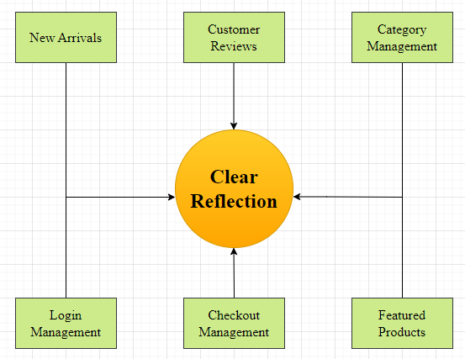

**2.4. FLOWCHART (System Flow Diagram)**

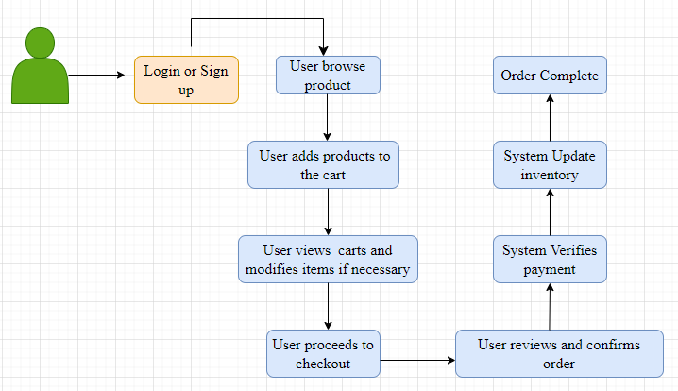

**Page # 9**

**PROTOTYPE (SCREEN SHOT OF THE PROJECT INTERFACE)**

1. **LOGIN PAGE**

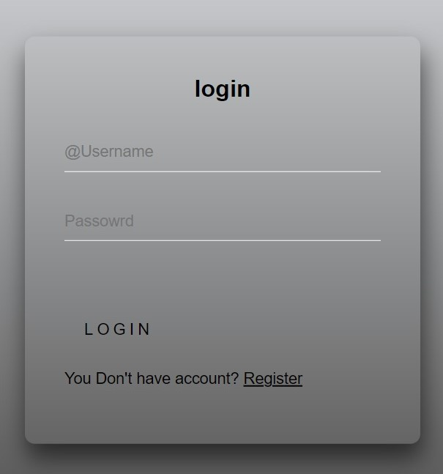

**2) SIGNUP PAGE**

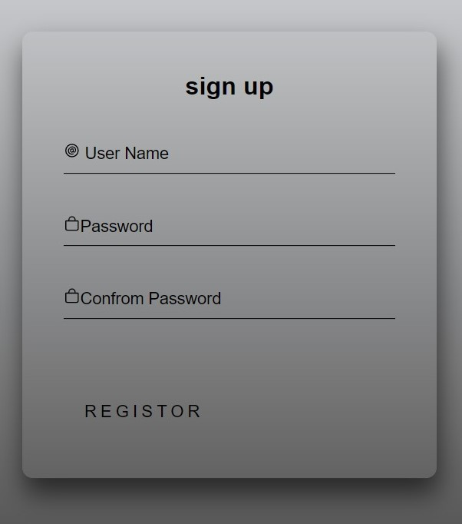

**Page # 10**

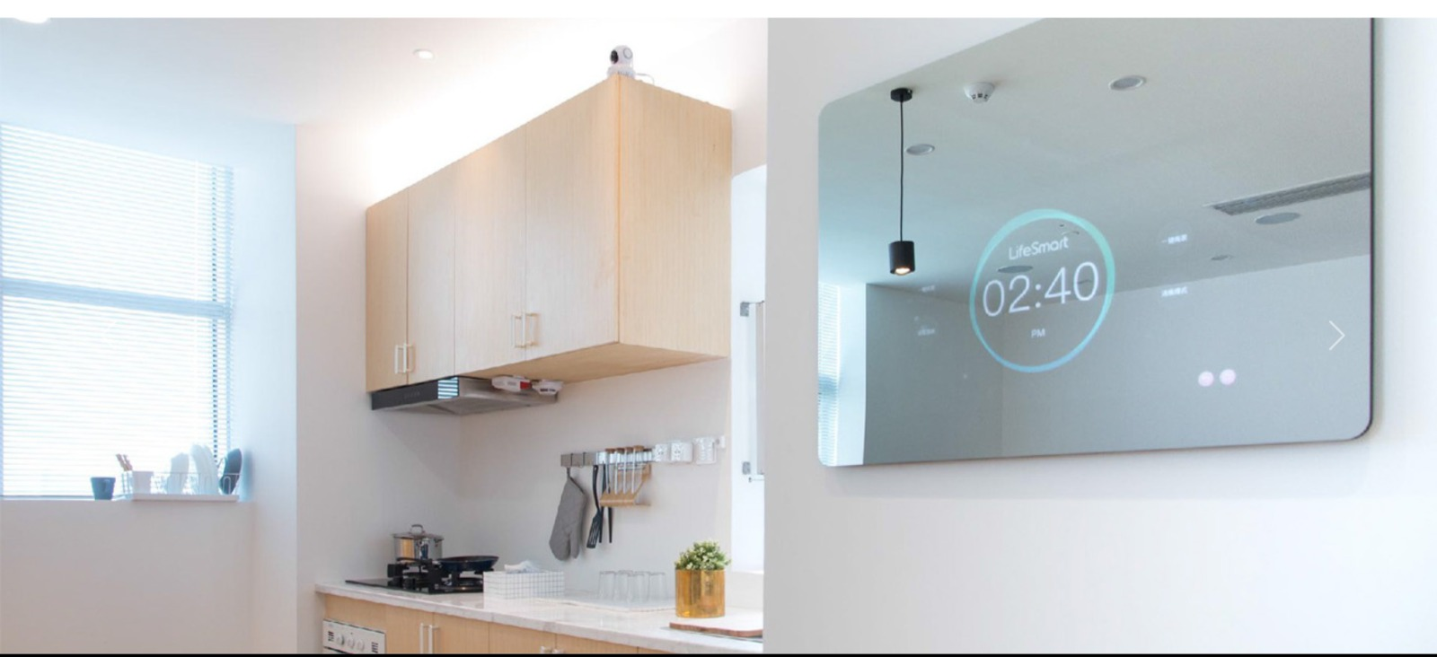 **1) HOME PAGE**

1. 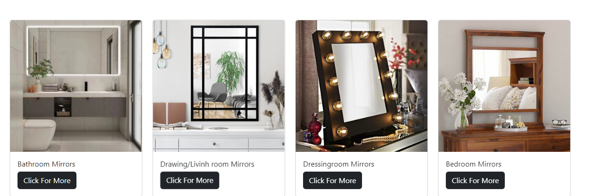**PRODUCTS PAGE**

**Page # 11**

1. 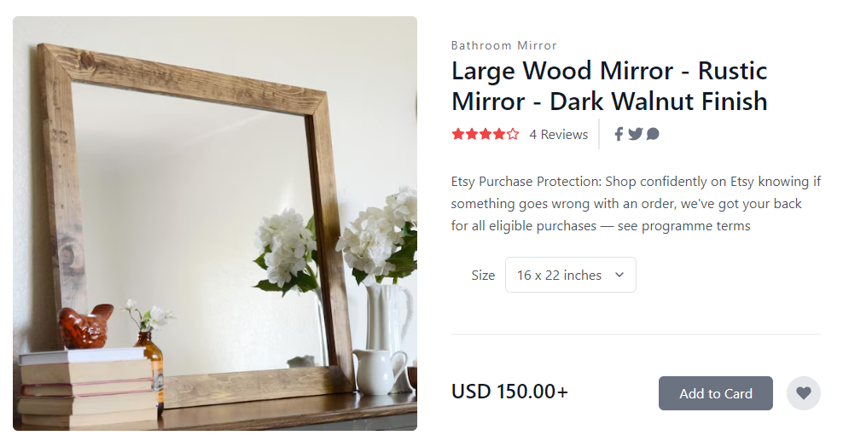**CART PAGE**

**CONCLUSION**

In conclusion, the project aims to design a modern and responsive e-commerce website that provides a seamless user experience. The website will be designed with a clean and modern layout, featuring a hero image or video, a navigation bar, and sections for featured products, new arrivals, and customer reviews. The product page will be designed to provide users with a comprehensive view of the product, including multiple images, descriptions, sizes, colors, and reviews. The cart and checkout pages will be optimized for ease of use, and the website will be designed to be responsive across all devices. Finally, the website will be thoroughly tested to ensure that it meets the highest standards for usability, functionality, and security. Overall, the website will provide users with a seamless shopping experience and will help to increase the online presence and revenue.

**Page # 12**